Animal housing and manure storage model in FASSET

1. Introduction

This model was constructed on the basis of the following principles;
- Flows of nutrients, dry matter and water should be traceable, such that the consequences of changes in excretion or management of a specific group of animals are reflected in the quantity and quality of the manure they produce.
- The model should be sufficiently mechanistic to allow the consequences of changes in animal house management on losses of pollutants to be simulated.
- The model should be adaptable to the range of housing and manure storage types found in practice.

2. The model

2.1 Animal housing - structure

An animal house is considered to contain one or more animal sections, where an animal section is defined as an area of the housing to which an identifiable group of animals is confined (see Fig 1). This will most commonly be identified with a pen or stall. For example, a pig house could contain separate sections containing dry sows, sows with suckling piglets and weaned piglets. The user defines the number of sections and within constraints of PC memory and speed, there can be an unlimited number of animal sections within a single animal house.

Each animal section consists of either one or two floor areas and each floor area can contain one or two manure types. For example, an animal section could contain an area that is slatted and an area that is solid. A floor area could contain a single manure (slurry or farmyard manure) or two manures (dung and urine separately). The user defines the type and number of animals, the number of floor areas within each section and the distribution of animal excreta deposited between floor areas. Furthermore, the user defines for each floor area, the type of manure contained, the storage capacity and the identity of the storage facility that receives manure from the floor. The storage facility can either be within the animal house (slurry pit or slurry channel) or external (slurry tank or manure stack). In the case of solid manure that is stored on the floor of the animal section until field application, no receiving storage facility is defined.

The animal house consists of both the animal sections and the associated gangway and storage areas. Although the latter do not contribute directly to emissions, their presence in part determines the volume of air contained within the animal house and therefore the effect of ventilation. The physical dimensions of animal house are defined by of plan area and mean wall height. The thermal properties required are the transmissivity of the materials used for walls and roof. For naturally ventilated animal housing, additional values must be provided for the height and width of apertures, the absorption coefficient, emissivity and external surface resistance of the roofing material. For housing with forced ventilation, the maximum and minimum ventilation capacity must be provided.

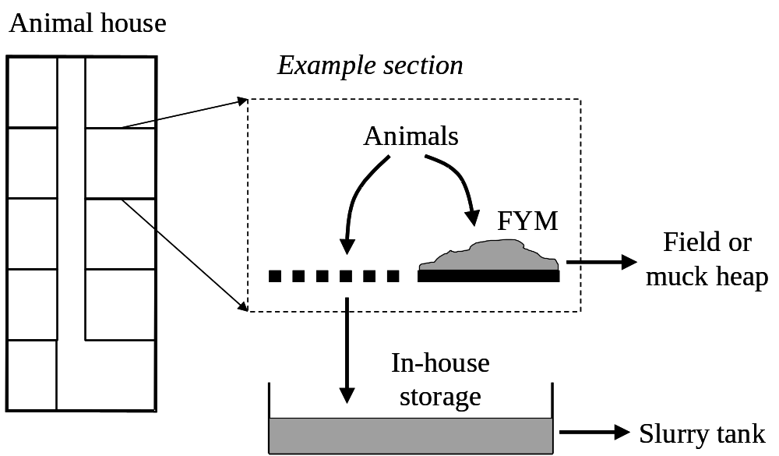

Fig 1 Schematic representation of animal housing and manure storage model

2.2 Animal housing – function

    - Overview

The animal house module uses the mass flow approach for carbon, nitrogen and water. A mass balance is maintained for each animal section. The animal section module contains functions that simulate the decomposition of organic matter in manure, the emission of carbon as carbon dioxide and methane and of nitrogen as ammonia, nitrous oxide and dinitrogen.

The inputs to the animal housing model are as follows;
- The quantity and quality of animal manure deposited daily in each animal section (this is normally done by an animal model). The quality parameters are the total ammoniacal N, faecal N, dry matter content and pH.
- The frequency with which each animal section is washed and the amount of water used.
- The quantity and quality of bedding used in each animal section. The quality parameters are the total N and dry matter contents.
- Meteorological data (solar radiation, air temperature, wind speed, air humidity).
- The heat production of the animals (this can be provided by the animal model).
- The target inside air temperature (controlled ventilated housing only).

The ventilation rate is estimated that the scale of the housing, using a modified version of the Silsoe model (Cooper et al, 1998; see Appendix A). The air velocity inside the animal house is estimated from the ventilation rate and the plan area of the building. Water evaporation and ammonia emission are modelled separately for each floor area. The resistance to scalar transport (ammonia and water vapour) is estimated from the air velocity, using the model used by Aarnink (1997). This model includes an empirical parameter that can be used to calibrate emissions to observed values.

The evaporation of water in manure is estimated using the function for open water evaporation (based on air temperature, air humidity and the resistance to scalar transport). For ammonia emission, the partial pressure of ammonia is calculated using the conventional Henry’s Law and ammonium dissociation equations. The area of the emitting surface is equated with the floor area, the temperature of the emitting surface is equated to the inside air temperature and the manure pH is assumed to remain constant.

The model operates with a daily time step.

2.2.2 Ventilation

The model simulates the ventilation rate of animal houses with either control or free ventilation. In doing so, the model considers the housing to be a hollow rectangular box.

The details of the ventilation model are shown in Appendix A1.

2.2.2 Dynamics of carbon, nitrogen and water

Carbon, nitrogen and water enter the animal section in animal excreta, bedding and water used for washing. Although an animal section can contain one or two floors, for simplicity, only the situation in which there is one floor will be described here. In situations where there are two floors, all inputs are partitioned between the floors using a constant partitioning factor.

2.2.2.1 Carbon

The carbon balance within the section is as follows:

Where C_{t} (kg) is the organic carbon present at time t and C_{t+1} (kg) is the organic carbon present at time t+1. δ is the timestep (d). C_{u,t} and C_{f,t} are the carbon input in animal urine and faeces respectively, C_{b,t} is the carbon input in bedding, C_{CO2,t} and C_{CH4,t} is the carbon emitted as carbon dioxide and methane respectively and C_{exp,t} is the carbon exported from the animal section (to in-house or external storage, or directly to the field). All have units of kg d⁻¹. The values of C_{u,t} and C_{f,t} are determined by the number of animals present in the section and excretion of each animal. The former is an input and the matter is determined by the relevant animal model. C_{b,t} is determined by the number of animals present in the section and the mass of bedding used per animal per day. The latter is a constant that is dependent on the animal type and the manure management system (e.g. slurry, farmyard manure). C_{exp,t} is determined by the manure management model.

The emission of carbon species is modelled very simply. No attempt had been made to justify this model in relation to the scientific literature. The emission of C species is made a function of the degradation rate of organic carbon:
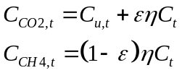
where η (d⁻¹) is the degradation rate and ε is a manure-type dependent partitioning constant.
The degradation rate is itself simulated using a first order function that depends on the manure type, temperature and moisture content:
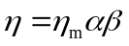
where η_{m} (d⁻¹) is a constant depending on manure type and α and β are moisture and temperature functions respectively.
The function α takes the form shown in Fig 2.

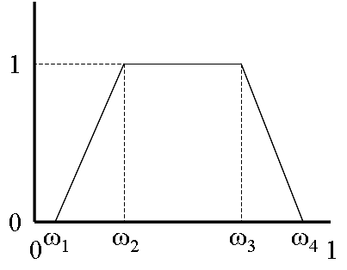
Fig 2
If the moisture content of the manure (ω) is between ω₁ and ω₂ then:
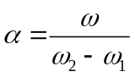
If ω is between ω₂ and ω₃ then ω=1. If ω is between ω₃ and ω₄ then:
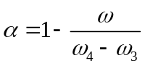
The function β takes the same form as for α but with the replacement of moisture content by temperature. Note that the function currently uses air temperature; there is no attempt to simulate the actual temperature of the manure.
2.2.2.2 Nitrogen
The model distinguishes between the following forms of nitrogen; NH₄⁺-N, NO₃-N and organic nitrogen. The NH₄⁺-N is increased by the addition of nitrogen in urine and by the mineralisation of organic nitrogen and is decreased by nitrification and the volatilisation of ammonia:
where N_{NH4,t} and N_{NH4,t+1} are the amounts of ammoniacal nitrogen at time t and t+1 respectively (kg), φ_{t} is the rate of nitrification (d⁻¹), κ_{t} is the rate of volatilisation of ammonia (d⁻¹), N_{u,t} is the nitrogen added in urine (kg d⁻¹), N_{org,t} is the organic nitrogen at time t (kg) and N_{NH4,exp,t} is the rate of export of ammoniacal nitrogen to external manure storage or field application (kg d⁻¹).
The NO₃-N is increased by nitrification and decreased by denitrification:
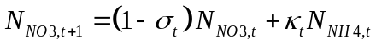

Where N_{NO3,t} and N_{NO3,t+1} are the amounts of NO₃-N at time t and t+1 respectively (kg), and σ_{t} is the rate of denitrification.

The dynamics of inorganic nitrogen are as follows:

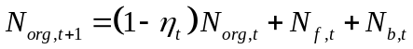

Where N_{org,t} and N_{org,t+1} are the amounts of organic nitrogen at time t and t+1 respectively (kg), N_{f,t} and N_{b,t} are the amounts of nitrogen added in faeces and bedding respectively.

2.2.2.3 Water

Water is added to an animal section in urine, faeces, bedding and washing water.

Got here

Manure storage – structure

A manure store has a surface area and a depth. It can either be located inside an animal house or externally.

Manure storage – function

Manure storage receives manure from the animal housing and hard standings. Manure is removed for application to the fields or for export from the farm.

The following processes are simulated;
- Water evaporation.
- Ammonia volatilisation. The slurry tanks this is calculated using the method of Olesen and Sommer (1994). This includes empirically determined resistances that allow emissions from covered and uncovered tanks to be calibrated to measurements. The solid manure storage, a different model is used.

References

Aarnink (where is it?)

K. Cooper, D. J. Parsons, and T. Demmers. A thermal balance model for livestock buildings for use in climate change studies. Journal of Agricultural Engineering Research 69 (1):43-52, 1998.
J. E. Olesen and S. G. Sommer. Modelling effects of wind speed and surface cover on ammonia volatilization from stored pig slurry. Atmospheric Environment 27:2567-2574, 1994.
A1 Ventilation model
The major simplification made in comparison with the animal house model of Cooper et al (1998) is that the building is considered to be square in plan and no account is taken of the orientation relative to the compass.

Controlled ventilation
Heat is lost from the animal house by transmission through the walls and roof and in the ventilation air.
The animal house is defined in terms of the plan area (a_{p}; m²) and the wall height (h; m). The surface area of wall (a_{w}; m²) is then:
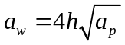
If the outside air temperature (θ; K) is below the target inside temperature (θ_{T}; K), the following equation must be true, if the inside temperature is to be maintained at θ_{T}.
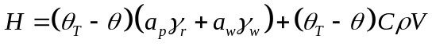
where H (MJ d⁻¹) is the sensible heat generated by the livestock present, γ_{r} and γ_{w} are the thermal transmissivities of the wall and roof materials respectively (W m⁻² K⁻¹), C is the specific heat of the air (MJ kg⁻¹ K⁻¹), ρ is the air density (kg m⁻³) and V is the ventilation rate required to maintain θ_{T} (m³ s⁻¹).
V is therefore given by:
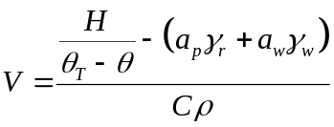
If V is calculated to be greater than the maximum ventilation rate (V_{max}; m³ s⁻¹), or θ >=θ_{T}, V = V_{max} and the temperature inside the housing (θ_{i};K) is given by:
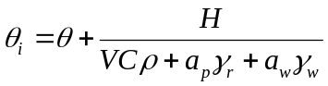
If V is below the minimum ventilation rate (V_{min}; m³ s⁻¹), supplementary heating H_{s} (W) is applied, given by:
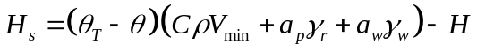
If the supplementary heating necessary to maintain θ_{T} exceeds the maximum heating capacity of the housing (H_{smax}; MJ d⁻¹), the inside temperature is given by equation , replacing H with (H+H_{smax}).

Free ventilation
Using notation of Cooper et al 1998.
Assumptions
- The temperature remains above some minimum, T_{min} (C)
- The aim is to maintain the air velocity at some specified value, v_{opt} (ms⁻¹).
- If the inside temperature exceeds some specified maximum desirable value, T_{max} (C), the farmer will seek to increase ventilation, even if the air velocity will exceed the previously specified value.
- The ventilation aperture is expressed as a proportion (p) of the wall height that is open to the wind. The minimum and maximum ventilation is determined by the maximum and minimum apertures (p_{max} and p_{min} respectively).
The inside temperature is first calculated, assuming that the ventilation is such that the air velocity (v; m^{s-1}) is v_{opt}.
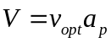
The temperature difference between inside and out can be calculated according to the equation for forced ventilated housing from Cooper et al (1998):
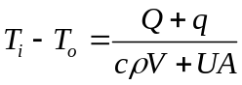
Where Q is a total sensible heat output per animal (W), c is the specific heat of air (J K⁻¹ kg⁻¹), ρ is the density of air (kg m⁻³), U is the thermal transmittance (W m² K⁻¹), A
If T_{i} exceeds T_{max} or is less than T_{min}, V_{x} is calculated so that θ_{i} equates to the limiting temperature:
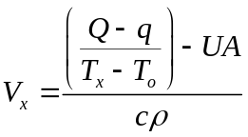
Where T_{x} is T_{max} or T_{min} as appropriate.
The value of V_{x} calculated must then be tested against the values obtained with p_{min} and p_{max}, to see if V_{x} can be achieved, given the current environmental conditions.
We here assume that the wind always blows perpendicular to one wall. The housing is assumed here to be square, so the length of each wall is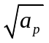. The wind-forced ventilation (V_{f}) is:
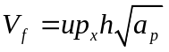
Where p_{x} is either p_{min} or p_{max}.
We assume here that the house has a flat roof and only the roof is exposed to the sky.
Calculate Tsol as Cooper eqn 9. Calculate UA from total surface area and difference between inside and outside temperature. Calculate q for roof (plan) area only. Calculate V using Cooper eqn 21.
Parameterisation

